**(MEETING ONE PHYSICAL)**

SOFTWARE PROJECT ENGINEERING (CMM004)



Team ID: Group F

Meeting Date: Tuesday, 28 January 2023.

Meeting Place: SOC waiting room

Duration: one hour

Meeting Purpose: Deliberating on the best to three project topics to submit to Kit.

Meeting Attendance: 8

# Members in Attendance

1. Joy Shangotola
2. Bolanle Okupa
3. Olatunbosun Ayomide
4. Abidemi Sanusi
5. Samson Oluwadamilare Odubanjo
6. Timothy Ezeokoli
7. Akolade Daniels Towolawi
8. Babatunde Sulu

# Agenda

* Get to know each members of the group F.
* Assigning a member of the team who will continuously compile all the minutes of each meetings held going forward.
* Deliberating on over 19 topics suggested by each members of the team.

# Challenges

* Finding a suitable place where future meetings can be held, with no distractions.
* Streamlining all 19 topics to just 3, to submit to kit for project commencement.
* Sticking to said time for all meetings, and ending all meetings at the agreed time, with no side attractions.

# Action Point(s)

* A whatsapp group was created, where notifications and very important messages will be sent to every member of the group.
* Group assigned a member of the team, who will be in charge of reminding every team members all future meetings and the agenda for each meetings.
* Group assigned a member of the team, who collates the minutes of each meeting and summarizes it up, as a proof of our joint effort, for the project.

**(MEETING TWO PHYSICAL)**

Team ID: Group F

Meeting Date: Tuesday, 31 January 2023.

Meeting Place: SOC waiting room

Duration: one hour

Meeting Purpose: Still Deliberating on the best to three project topics to submit to Kit.

Meeting Attendance: 8

# Members in Attendance

1. Joy Shangotola
2. Bolanle Okupa
3. Olatunbosun Ayomide
4. Abidemi Sanusi
5. Samson Oluwadamilare Odubanjo
6. Timothy Ezeokoli
7. Akolade Daniels Towolawi
8. Babatunde Sulu

# Agenda

* Streamlining all 19 project topics ideas to just 3 for submission.

# Challenges

* Fine-tuning each project topic ideas, in a way that it explains in clear terms, what it does and the problem it solves for the user.
* A member of the team, had some challenges with figuring out how to put finishing touches on the bicycle tracker, and school was not willing wo give out any further information on it.

# Action Point(s)

* Three topics were picked and submitted to Kit namely:

1. Travel guide app that allows people to become familiar with different geographical locations.
2. Hospital management system with instant messaging feature between patients and health experts.
3. An E commerce website, where buyers and sellers meet to transact.

# Topic Allocation

* An Online Retail Platform. An E commerce website, where buyers and sellers meet to transact, was allocated to team F by Mr Kit.



**(MEETING THREE PHYSICAL)**

Team ID: Group F

Meeting Date: Tuesday, 31 January 2023.

Meeting Place: Library 9th floor, group project meeting room.

Duration: one hour.

Meeting Purpose: Working on possible product backlogs.

Meeting Attendance: 8

# Members in Attendance

1. Joy Shangotola
2. Bolanle Okupa
3. Olatunbosun Ayomide
4. Abidemi Sanusi
5. Samson Oluwadamilare Odubanjo
6. Timothy Ezeokoli
7. Akolade Daniels Towolawi
8. Babatunde Sulu

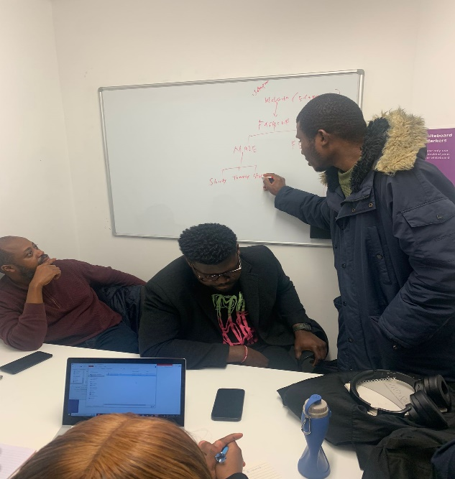

# Agenda

* Working on the approved topic.
* Creating a repository (git hub).
* Drafting the Architectural Design for the E commerce website.

# Challenges

* Finding a suitable niche for the website.
* Identifying what to include in the product backlog.
* Drafting the architectural design of the website, without involving unnecessary and confusing items in the website.

# Action Point(s)

* Possible product backlogs, the team was able to come up with are:

1. Encourage fast service delivery for customers.
2. Ensure flexibility for customers.
3. Create product listings on the site for the user.

# Scrum Master Allocation

* The Scrum Master allocated to us was HAMID FARHADI TOLIE.

Team ID: Group F

Meeting Date: Thursday, February 9th, 2023.

Meeting Place: Microsoft Teams

Duration: one hour

Meeting Purpose: First Meeting with the scrum master.

Meeting Attendance: 8

# Members in Attendance

1. Joy Shangotola
2. Bolanle Okupa
3. Olatunbosun Ayomide
4. Abidemi Sanusi
5. Samson Oluwadamilare Odubanjo
6. Timothy Ezeokoli
7. Akolade Daniels Towolawi
8. Babatunde Sulu

# Agenda

* Identifying our product backlogs and sprint backlogs.

# Challenges

* Trying to involve too many technicalities in the product backlog.
* Not fully understanding what should be added to the list of the product backlogs

# Action Point(s)

* Product backlogs were listed by the team namely:

1. The Homepage of the Product (index.html)
2. Product database development.
3. Owner should be able to upload items for sale
4. Buyer should be able to create an account, sign-in with e-mail and password
5. Buyer/Visitor should be able to view and access items
6. Buyer should be able to search for items by category and price.
7. Buyer should be able to pay for selected items in the website cart.
8. Buyer should be able to purchase and apply for online delivery.

* **Sprint 1 ( 6days Effort level)**

Creating home page using html, css, and java script

* **Sprint 2 ( 5days Effort level)**

Creating database using php and MySQL

* **Sprint 3** **( 5days Effort level)**

Development of the product page

* **Sprint 4 ( 5days Effort level)**

Buyer should be able to create an account, sign-in with e-mail and password

* **Evaluation Criteria (sprint 1)**

Home page should be successfully launched in the web browser.

* **Evaluation Criteria (sprint 2)**

Successful deployment of database

* **Evaluation Criteria (sprint 3)**

Seller should be able to upload products, specify the price, and categorize the items

* **Evaluation Criteria (sprint 4)**

User is able to register/login



Team ID: Group F

Meeting Date: Thursday, February 11th, 2023.

Meeting Place: Microsoft Teams

Duration: one hour

Meeting Purpose: Post-Scrum Meet (Allocation/delegation of tasks)

Meeting Attendance: 8

# Members in Attendance

1. Joy Shangotola
2. Bolanle Okupa
3. Olatunbosun Ayomide
4. Abidemi Sanusi
5. Samson Oluwadamilare Odubanjo
6. Timothy Ezeokoli
7. Akolade Daniels Towolawi
8. Babatunde Sulu

Summary Of the Meeting: Designation of tasks as follows:

1. Creation of the database design
2. Interface Design
3. Linking Interface and Data base
4. Picture Upload

Team ID: Group F

Meeting Date: Wednesday, February 22nd, 2023.

Meeting Place: Physical SOC lab

Duration: one hour

Meeting Purpose: Review of tasks and way forward as per challenges encountered

Meeting Attendance: 8

# Members in Attendance

1. Joy Shangotola
2. Bolanle Okupa
3. Olatunbosun Ayomide
4. Abidemi Sanusi
5. Samson Oluwadamilare Odubanjo
6. Timothy Ezeokoli
7. Akolade Daniels Towolawi
8. Babatunde Sulu

Summary of the meeting:

The Home page was created and 70 percent optimal as the back end is still a challenge. This is however justifiable as PHP has just recently been taught in the Labs . The designs have also been implemented to an extent however, this is still work in progress as research is still ongoing and more ideas are still being considered. Activities/ reviews are actively been committed to the repository and progress is being made.



Team ID: Group F

Meeting Date: Saturday, February 25th, 2023.

Meeting Place: teams call

Duration: one hour

Meeting Purpose: Review of tasks and way forward as per challenges encountered

Meeting Attendance: 8

# Members in Attendance

1. Joy Shangotola
2. Bolanle Okupa
3. Olatunbosun Ayomide
4. Abidemi Sanusi
5. Samson Oluwadamilare Odubanjo
6. Timothy Ezeokoli
7. Akolade Daniels Towolawi
8. Babatunde Sulu

Summary of the meeting:

* Mastering the use of repository for effective team coordination.
* Database backend challenges.
* Preparing for Kit and scrum master meeting next week.
* Sprint report review and coordination to match the effort displayed so far.



Team ID: Group F

Meeting Date: Wednesday, March 1st, 2023.

Meeting Place: Zoom

Duration: one hour

Meeting Purpose: Officially reminding the group of the visit of the scrum master, to be held tomorrow, and adding finishing touches on our sprint backlog.

Meeting Attendance: 8

# Members in Attendance

1. Joy Shangotola
2. Bolanle Okupa
3. Olatunbosun Ayomide
4. Abidemi Sanusi
5. Samson Oluwadamilare Odubanjo
6. Timothy Ezeokoli
7. Akolade Daniels Towolawi
8. Babatunde Sulu

# Agenda

* Notifying the Team, that Kit would be added to the git hub repository.
* Team shared knowledge on git hub and repository management, file management and smooth accessibility.
* Officially reminding the group of the visit of the scrum master, to be held on the 2nd of March, 2023.

# Challenges

* Tried creating database for the backend user account registration and login, and for the product database, but we were successful.

# Recommendations

Way forward, we are learning php at 007 class and the team should be able to complete it by next week.

.

Team ID: Group F

Meeting Date: Thursday, March 2nd, 2023.

Meeting Place: Zoom

Duration: one hour

Meeting Purpose: Meeting with the Scrum Master-Kyle Mcpherson

Meeting Attendance: 8

# Members in Attendance

1. Joy Shangotola
2. Bolanle Okupa
3. Olatunbosun Ayomide
4. Abidemi Sanusi
5. Samson Oluwadamilare Odubanjo
6. Timothy Ezeokoli
7. Akolade Daniels Towolawi
8. Babatunde Sulu

# Agenda

* Review of the sprint back logs

# Challenges

* The backend still unresolved
* Review of the payments by the buyer and Delivery option by the seller

# Recommendations

1. XAMP/WAMP server to be installed.
2. MySQL to be downloaded and installed.
3. Codyhouse.co recommended for payment.
4. A form could be introduced to cater for the delivery of items to conclude that it is successful.

The scrum master encouraged the team and also indicated that the home page is very good.

Team ID: Group F

Meeting Date: Tuesday, March 7th, 2023.

Meeting Place: Cafereria

Duration: one hour

Meeting Purpose: Change of website template,Implementation of backend.

Meeting Attendance: 8

# Members in Attendance

1. Joy Shangotola
2. Bolanle Okupa
3. Olatunbosun Ayomide
4. Abidemi Sanusi
5. Samson Oluwadamilare Odubanjo
6. Timothy Ezeokoli
7. Akolade Daniels Towolawi
8. Babatunde Sulu

# Agenda

* Implementation of backend

# Challenges

* The backend still unresolved

# General Review

* After a general feedback from the scrum master from what we have done so far, the backend technicality and functionality is still in progress.

Team ID: Group F

Meeting Date: Thursday, March 14th, 2023.

Meeting Place: cafeteria

Duration: one hour

Meeting Purpose: Putting finishing touches on the backend

Meeting Attendance: 8

# Members in Attendance

1. Joy Shangotola
2. Bolanle Okupa
3. Olatunbosun Ayomide
4. Abidemi Sanusi
5. Samson Oluwadamilare Odubanjo
6. Timothy Ezeokoli
7. Akolade Daniels Towolawi
8. Babatunde Sulu

# Agenda

* Creating a proper interaction between the login page and the account creating page.
* Creating a prompt page, that shows up immediately after the registration is done on the site.

# Challenges

* Search bar not yet completed (minor challenge)
* Struggling with getting the thank you page.
* Struggling with linking up the account creation page and the login page.

# Recommendations

* Picture quality of downloaded pictures to be downloaded on the website, are too low, we are to delete and download new pictures with higher resolutions and with a white background.
* Our about us page does not have volume, needs more content.
* Update scrum projects push it regularly to the git hub repositories from time to time.